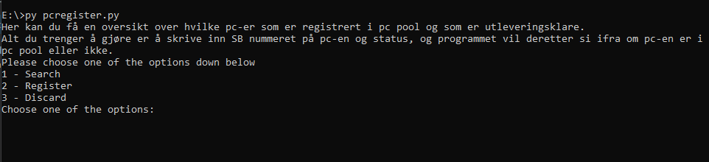

Choose one of the options

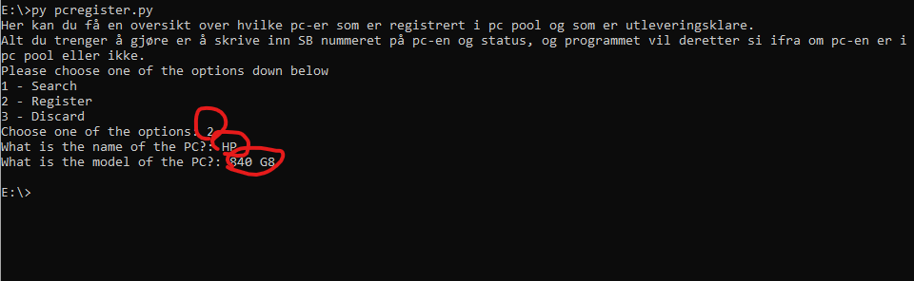

User inputs

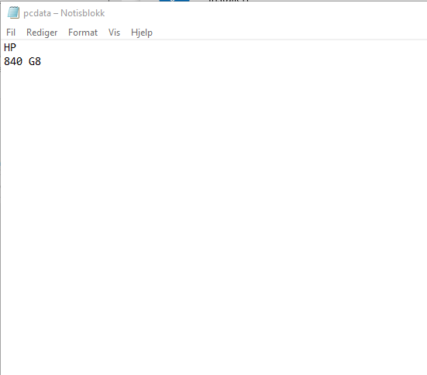

Open the txt file and you will see the stored data.